Assignment 29.2

Problem Statement:

Write a hive UDAF to find the largest integer in a column. Use your own dataset for the above problem statement and attach the steps performed, codes used with the result.

Creating UDAF class

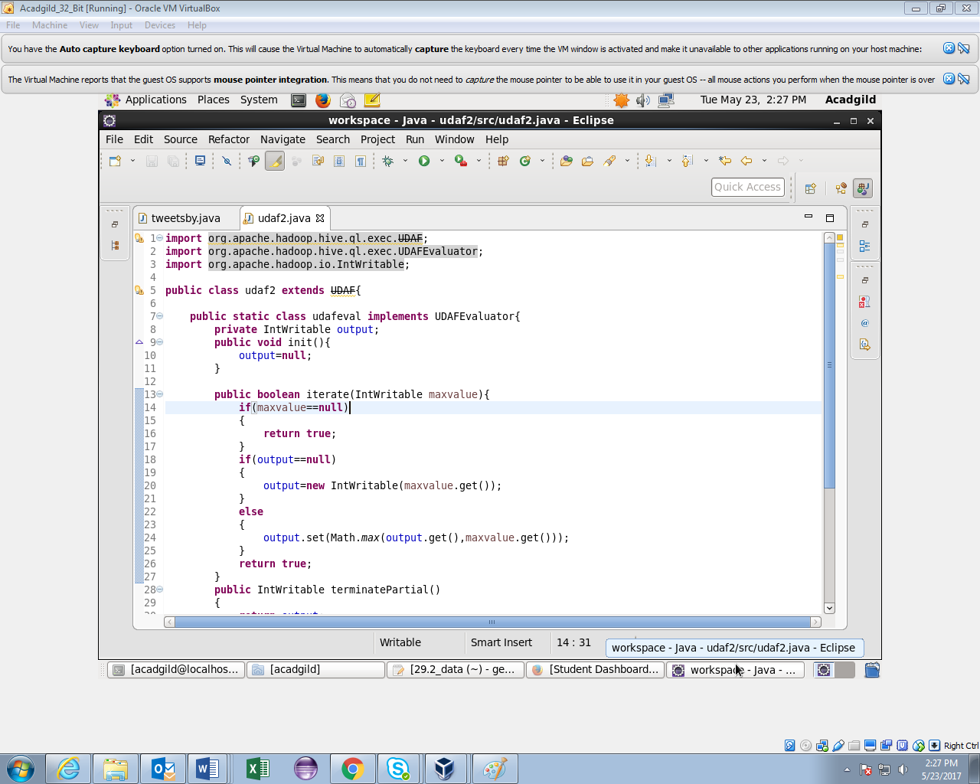

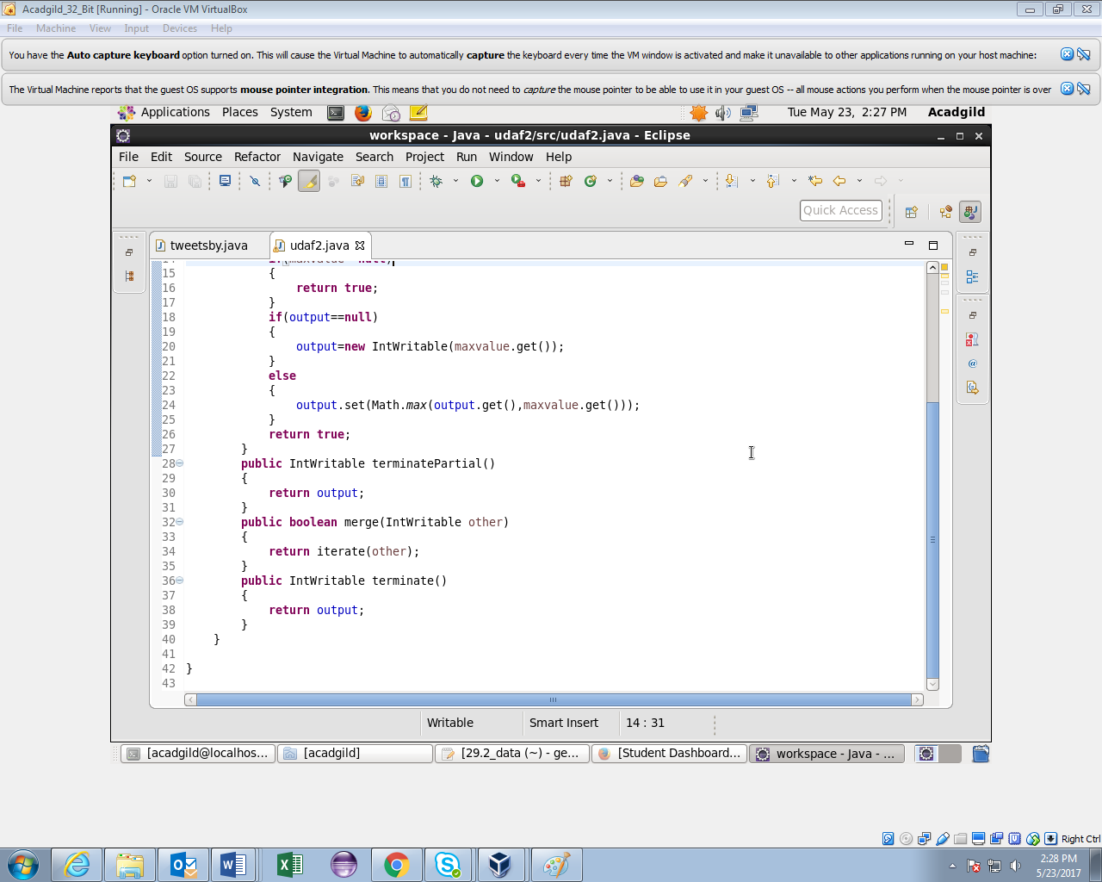

Creating table and loading data in it.

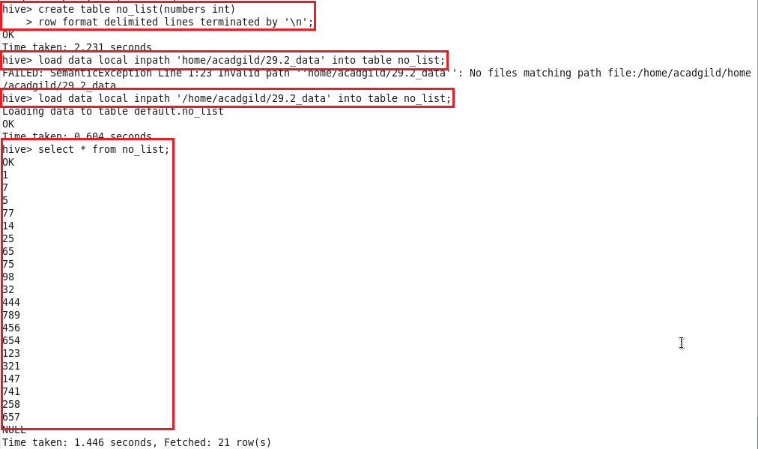

Adding jar and creating temporary function using UDAF

